**Chapter 7 - Quiz**

1. What two commands determine whether auto-summarization is in effect for RIP? (Choose two.)
2. show running-config
3. show ip route
4. show ip interface
5. show interface
6. show ip protocols
7. Which statement regarding RIP v2 is correct?
8. RIP version 2 auto-summarizes with the most efficient mask.
9. RIP version 2 auto-summarizes at the major network boundary.
10. RIP version 2 requires manual configuration for summarizing routes.
11. By default, RIP version 2 and RIP version 1 do not handle route summarization the same way.
12. What is the default behavior of the RIP routing protocol if no version type is specified?
13. send and receive version 1 updates only
14. send version 1 updates only, receive version 1 and 2 updates
15. receive version 1 updates only, send version 1 and 2 updates
16. send and receive both version 1 and 2 updates
17. What condition would RIP v2 allow that RIP v1 would not allow?
18. 16 hops from one end of the network to the other
19. redistribution of EIGRP
20. 192.168.0.0 /16 network
21. router with more than three interfaces
22. How do RIP v1 and RIP v2 differ?
23. Only RIP v1 provides authentication in its updates.
24. Only RIP v1 uses split horizon to prevent routing loops.
25. Only RIP v2 uses 16 hops as the metric value for infinite distance.
26. Only RIP v2 sends subnet mask information with its routing updates.
27. Refer to the following topology description and partial results from the debug i p rip events command on router B to answer the question.

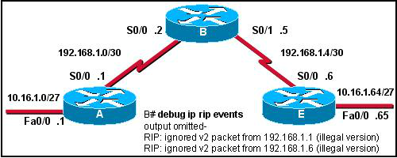

Question: What is the likely cause of the debug messages?

1. Routers A and E are sending malformed updates.
2. RIP configuration on router B does not include networks connected to the serial interfaces.
3. Router B serial interfaces are not configured correctly.
4. Router B is running a different version of RIP than A and E.
5. Refer to the following topology description and the output of the show i p route command to answer the question. If all routers are running RIP version 2, why is there no route for the 192.168.1.32/27 network?

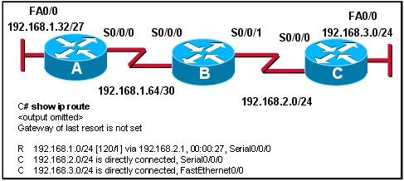

Question: If all routers are running RIP version 2, why is there no route for the 192.168.1.32/27 network?

1. Rip version 2 does not send subnet masks in its updates.
2. Router A is not set up with RIP as a routing protocol.
3. Rip version 2 auto summarizes routes by default.
4. Router B is not set up to advertise the 192.168.1.64/30 network.
5. Refer to the partial results from the **debug ip rip events** command to answer the question.

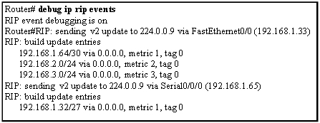

Question: What can be determined from this output?

1. A **show ip route** on a router two hops away will see the 192.168.1.32 /27 network in its routing table.
2. The Serial0/0/0 interface is configured with the **passive interface** command.
3. The router is passing the subnet mask along with the network in its updates.
4. All the routers must be Cisco routers because the network is using RIP version 2.